Contents

Overview of Program 2

Program Structure 3

Description of Functions 4

Description of Data Structures 6

Global Variables 7

Cross References 8

Index 13

# Overview of Program

The system is a simple operating system that is still in development. The current functionality is still very limited but the current plan is to progress with the project and improve the Operating System. The newest update has brought PCB control to the system.

# Program Structure

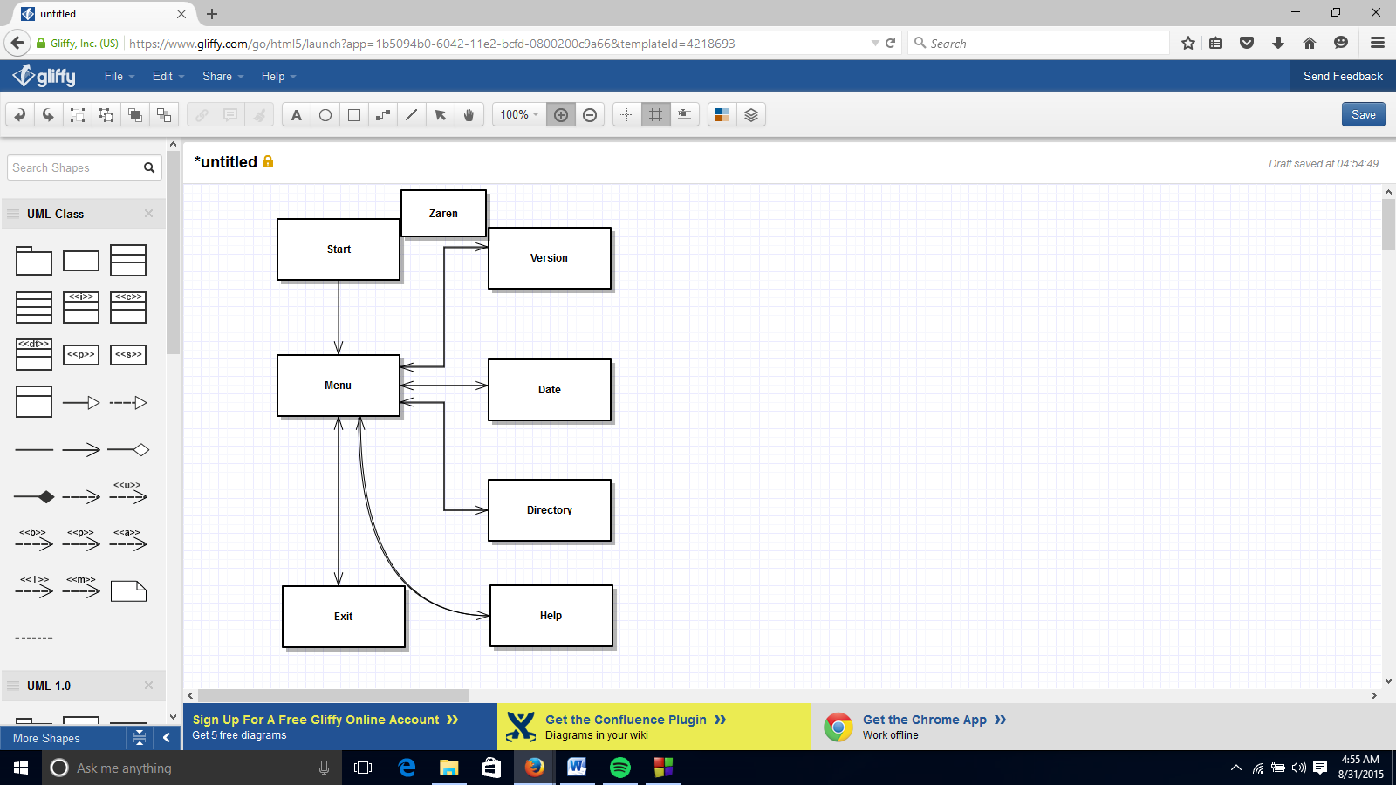

# Description of Functions

Start: No parameters. No return value. Starts up the OS and then moves to menu.

Menu: No parameters. No return value. Directs user around Operating System.

Version: No parameters. No return value. Displays version and returns to menu.

Date: No parameters. No return value. Displays date and time and returns to menu.

Directory: No parameters. No return value. Displays all file in current directory.

Exit: No parameters. No return value. Prompts user for confirmation to exit and then either returns to menu or exits program.

Help: No parameters. No return value. Displays information on other commands.

AllocatePCB: No parameters. Returns PCB pointer. Creates memory for PCB.

FreePCB: PCB Pointer. No return value. Frees memory from a PCB.

SetupPCB: String name, int priority, int class. Returns PCB pointer. Initializes a PCB.

FindPCB: String name. Returns PCB pointer. Searches queues for process of given name.

InsertPCB: PCB pointer. No return value. Inserts given PCB into appropriate queue.

RemovePCB: PCB pointer. No return value. Removes PCB from current queue.

ShowQueue: Int queue number. No return value. Displays queues based on queue number to screen.

ShowPCB: PCB Pointer. No return value. Displays information on PCB on single line.

PCBUserControls: No parameters. No return value. Give user PCB commands.

Suspend: No parameters. No return value. Take name from user. It then suspends the PCB with given name.

Resume: No parameters. No return value. Take name from user. It then resumes the PCB with given name.

SetPriority: No parameters. No return value. Takes name and priority from user. It then changes the PCB with given name to given priority.

ShowPCB: No parameters. No return value. Takes name from user. It then displays the information of PCB with given name.

ShowALL: No parameters. No return value. Shows all PCB from all queues.

ShowReady: No parameters. No return value. Shows all PCB from ready queue.

ShowBlocked: No parameters. No return value. Shows all PCB from blocked queue.

ReadFile: No parameters. Returns vector schedule. Reads processes from file.

SJF: No parameters. No return value. Schedules using shortest job first.

FIFO: No parameters. No return value. Schedules using first in first out.

STCF: No parameters. No return value. Schedules using shortest to completion first.

FPPS: No parameters. No return value. Schedules using fixed priority pre-emptive scheduling.

RR: No parameters. No return value. Schedules using round robin.

MLFQ: No parameters. No return value. Schedules using multilevel feedback queue.

LS: No parameters. No return value. Schedules using lottery schedulering.

# 

# Description of Data Structures

# Global Variables

# Cross References

**Start:**

Calls: Menu

Called by: N/A

**Menu:**

Calls: Menu, Version, Date, Directory, Help, Exit, PCBUserControls

Called by: Start, Menu, Version, Date, Directory, Help, Exit, PCBUserControls

**Version:**

Calls: Menu

Called by: Menu

**Date:**

Calls: Menu

Called by: Menu

**Directory:**

Calls: Menu

Called by: Menu

**Exit:**

Calls: Menu, Exit

Called by: Menu, Exit

**Help:**

Calls: None

Called by: Menu

**AllocatePCB:**

Calls: N/A

Called by: SetupPBC

**FreePCB:**

Calls: N/A

Called by: deletePBC

**SetupPBC:**

Calls: AllocatePBC, FindPBC

Called by: ReadFile

**FindPCB:**

Calls: N/A

Called by: setupPCB, suspend, resume, setPriority, showPCB,

**InsertPCB:**

Calls: N/A

Called by: suspend, resume

**RemovePCB:**

Calls: N/A

Called by: suspend, resume

**ShowQueues:**

Calls: ShowPCB

Called by: showAll, showReady, showBlocked

**ShowPCB:**

Calls: N/A

Called by: ShowQueues

**PCBUserControls:**

Calls: Suspend, Resume, SetPriority, ShowPCB, Show All, ShowReady, ShowBlocked, SJF, FIFO, STCF, FPPS, RR, MLFQ, LS , Menu

Called by: Menu

**Suspend:**

Calls: FindPCB, RemovePCB, InsertPCB.

Called by: Menu

**Resume:**

Calls: FindPCB, RemovePCB, InsertPCB.

Called by: Menu

**Set Priority:**

Calls: FindPCB

Called by: Menu

**Show PBC:**

Calls: FindPCB

Called by: Menu

**Show All:**

Calls: ShowQueues

Called by: Menu

**Show Ready:**

Calls: ShowQueues

Called by: Menu

**Show Blocked:**

Calls: ShowQueues

Called by: Menu

**Read File:**

Calls: SetupPCB

Called by: SJF, FIFO, STCF, FPPS, RR, MLFQ, LS

**SJF**

Calls: ReadFile

Called by: PCBUserControls

**FIFO**

Calls: ReadFile

Called by: PCBUserControls

**STCF**

Calls: ReadFile

Called by: PCBUserControls

**FPPS**

Calls: ReadFile

Called by: PCBUserControls

**RR**

Calls: ReadFile

Called by: PCBUserControls

**MLFQ**

Calls: ReadFile

Called by: PCBUserControls

**LS**

Calls: ReadFile

Called by: PCBUserControls

# 

# Index

**AllocatePCB 4, 9**

**CreatePCB 10**

**Date 4, 8**

**Directory 4, 8**

**Exit 4, 8**

**FIFO 5, 11**

**FindPCB 4, 9, 10**

**FPPS 5, 11**

**FreePCB 4, 9**

**Help 4, 8**

**InsertPCB 4, 9, 10**

**LS 5, 12**

**Menu 4, 8, 9, 10, 11**

**MLFQ 5, 11**

**PCBUserControls 4, 10**

**Read File 11**

**ReadFile 5**

**RemovePCB 4, 9, 10**

**Resume 4, 10**

**RR 5, 11**

**Set Priority 10**

**SetPriority 4**

**SetupPBC 9**

**SetupPCB 4**

**Show All 10**

**Show Blocked 11**

**Show PBC 10**

**Show Ready 10**

**ShowALL 5**

**ShowBlocked 5**

**ShowPCB 4, 5, 9, 10**

**ShowQueue 4**

**ShowQueues 9**

**ShowReady 5**

**SJF 5, 11**

**Start 4, 8**

**STCF 5, 11**

**Suspend 4**

**Version 4, 8**